REACT HANDS ON 10

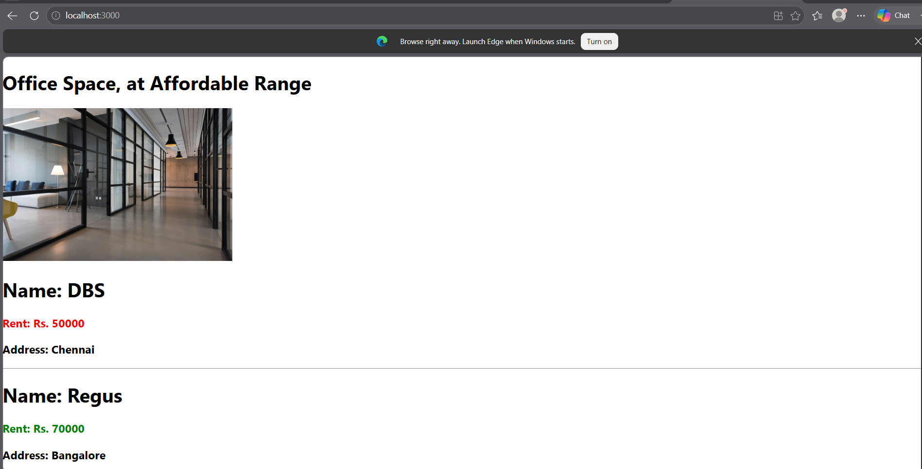

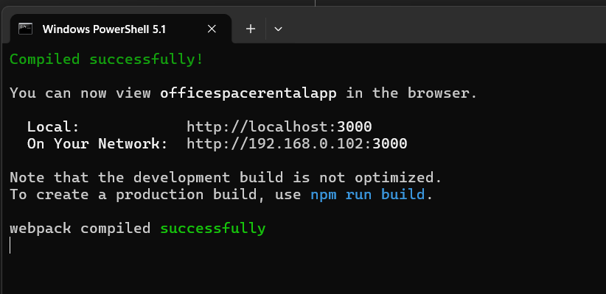

APP.CSS
.textRed {
color: red;
}

.textGreen {
color: green;
}

APP.JS

import './App.css';

function App() {

const officeSpaces = [
{
Name: "DBS",
Rent: 50000,
Address: "Chennai"
},
{
Name: "Regus",
Rent: 70000,
Address: "Bangalore"
},
{
Name: "SmartWorks",
Rent: 55000,
Address: "Hyderabad"
}
];

const imageUrl =
"https://images.unsplash.com/photo-1497366754035-f200968a6e72";

const element = "Office Space";

return (
<div>

<h1>{element}, at Affordable Range</h1>

<img
src={imageUrl}
width="25%"
height="25%"
alt="Office Space"
/>

{
officeSpaces.map((item, index) => {

let colorClass = "";

if (item.Rent <= 60000) {
colorClass = "textRed";
}
else {
colorClass = "textGreen";
}

return (
<div key={index}>

<h1>Name: {item.Name}</h1>

<h3 className={colorClass}>
Rent: Rs. {item.Rent}
</h3>

<h3>
Address: {item.Address}
</h3>

<hr />

</div>
);
})
}

</div>
);
}

export default App;

